**Delhi Public Secondary School, Robertsganj Holiday Homework (2020-21)**

# Class – II

**The summer holiday homework is also available on school’s website i.e.** [**www.dpssrobertsganj.in**](http://www.dpssrobertsganj.in)

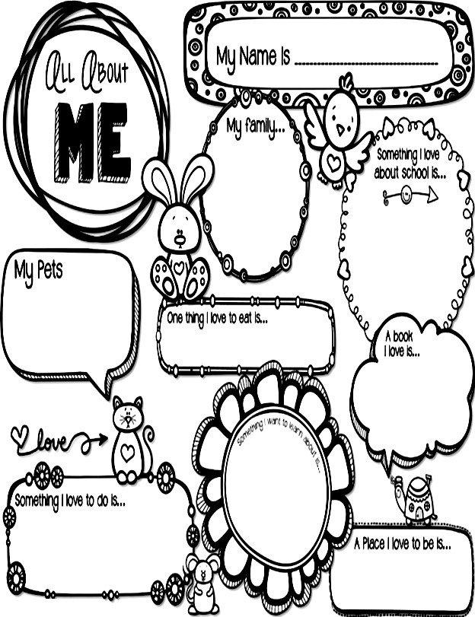

Dear Parents,

“Despite the hot Sun, we can still have a lot of fun , so vacation is here for a sweet retreat”. Summer holidays are round the corner and some fruitful activities are designed at DPS to enhance children’s creativity and innovation for the progressive learning.

Help your child to do it :

**•Morning Blessings:**Help your child inculcate good habits like doing

“Surya Pranam”& encourage him/her to greet all elders in the morning.

**•Fun in Knowing :** Tell the child about your childhood, share incidents from the past and show him/her old family albums. This will strengthen the bond between you and your child.

**•Fun with Books:** Encourage your child to read books with moral.

**•Fun with family:** Make use of these holidays and spend quality time together as a family and make your child feel special.

**•Fun with Parents**: Cook dinner together. Show your child how to measure 1 cup, 1/2 , 1 teaspoon etc. Start naming the food groups when you serve them.

* **Let your child help in your household chores like cleanings windows, dusting and many more.**

•Have walk together and talk to your child about what he/she likes and dislikes etc.

•Help your child to memorize the home address and your phone numbers too.

•Help your child in learning how to open and close his/her water

bottle, lunch box, school bag .

HOLIDAYS…. FUN TIME…… PARTY TIME !!

* + **Do one page cursive writing of English & Hindi daily in separate notebook.**
  + **Learn & Write three new words from dictionary daily.**

# MAKE YOUR HOME A PLACE FOR READING

Here are some tips to help parents of young children to promote reading at home.

* Choose a reading time for your child, as in before a nap, bedtime, or after dinner.
* Select an age appropriate book for your child.
* Hold the book so that he or she can see the pictures, if possible, also let him or her turn the pages.
* Take time to look at and talk about the pictures. Don’t just read the story: talk about it.
* Let your child point out the letters, shapes, colours and animals.
* Read aloud to your child every day.

# Social Development

Imbibe following Social Skills in your child:

Greeting with a smile when someone comes to the house, preferably in English. Conversing freely but politely with visitors, relatives coming over to the house.

Answering the phone calls with a polite “Hello!” . Also asking “May I know who is calling”.

Sitting at the dining table with the family to eat the meals, using proper table manners. Do not watch television while having meals with the family.

Sharing toys, colours etc. with siblings. Talk to your child about:

1. The importance of keeping our surroundings clean.
2. The good habit of sharing and making friends.
3. Encourage your child to water plants.
4. Encourage your child to respect and help the elders at home.
5. Encourage your child to develop the habit of taking care of his/her belongings.

# Happy Father’s Day (17th June)

“A dad is someone who holds you when you cry, scolds you when you break the rules,

shines with pride when you succeed and has faith in you even when you fail….”

Take your father for a nature walk observe the beautiful plants around you with him.

Collect leaves of different sizes and shapes. Take your mother’s help and make a

beautiful greeting for your father with leaf printing and also make a smiley inside it.

Surprise him by making sandwiches and lemonade in the breakfast for him with the help of your mother.

# Physical Development

* + Encourage your child to participate in dancing and singing activities.
  + Indulge your child in any one hobby like skating, basketball, dance, musical instruments, swimming tec.
  + Encourage your child to take care of ‘Personal Hygiene’ by inculcating the following habits:
  + Brushing teeth twice a day.
  + Combing hair regularly.
  + Bathing everyday.
  + Washing hands before and after meals.
  + Trimming the nails and keeping them clean.

# Inculcate following life skills in your child to help him/her become independent:

* + - Buttoning his/her shirt
    - Zipping and unzipping
    - Tying his/her shoes laces
    - Buckling and unbuckling
    - Turning pages of a book
    - Packing his/her school bags
    - Laying the table for dinner
    - Proper toilet training
    - Arranging shoes in the shoes rack

# Creative Development

* + **Create a beautiful craft using best out of waste material eg. Old cd, wool and news paper etc.**
  + **Create a beautiful scene with two living and two non living things on half size chart paper.**

# Subject - English

Q1.Colour the Common and Proper nouns as per the code given below.

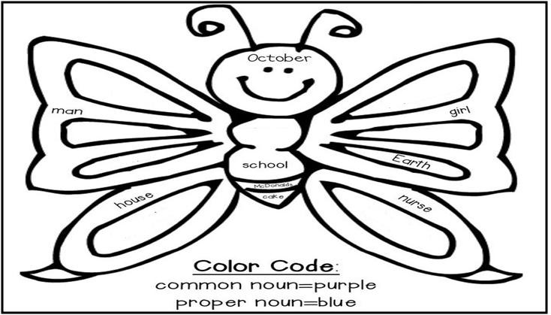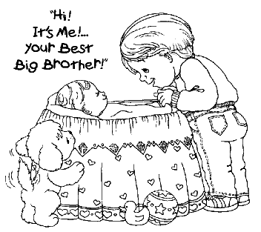

Q2.Read the short story and fill in the given blanks. My Baby Brother

I love my baby brother. His name is Atul. He sleeps a lot. When he cries, I try to cheer him up. He laughs when I make silly voices. Mum and Dad give us a lot of love and care.

1. My baby brother is called .
2. When he cries I

____.

______to our siblings.

1. We should give a lot of and

Q3.Pick out the rhyming word from the buckets and write down below in the space given.

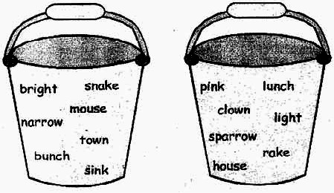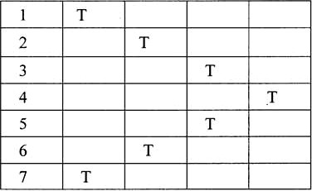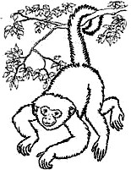

Take a word from each bucket that rhymes:

|  |  |  |
| --- | --- | --- |
| 1) | and |  |
| 2) | and |  |
| 3) | and |  |
| 4) | and |  |
| 5) | and |  |
| 6) | and |  |
| 7) | and |  |

Q4. Complete the nouns in the square using the clues given below:

* 1. A monkey has a long
  2. I saw him at the bus
  3. “ What is the today”?
  4. Birds build this
  5. The boy is flying a
  6. A twinkles in the sky at the night.
  7. Parrot is sitting on the .

# RIDDLES AND CODES

Use the secret code given below to answer these

1. What can run but can’t walk? 20 2 12 6 5
2. What has hands but no arms? 19 17 3 19 1
3. What is made that can’t be seen? 9 3 16 13 6
4. What goes up and down without ever moving? 13 12 2 16 5 19 2 13 6
5. What belongs to you but is used more by others? 8 3 7 5 9 2 15 6

**Subject - Mathematics**

Q1. Arrange in increasing order.

|  |  |  |  |  |  |  |  |  |  |  |  |  |  |  |  |  |  |  |  |
| --- | --- | --- | --- | --- | --- | --- | --- | --- | --- | --- | --- | --- | --- | --- | --- | --- | --- | --- | --- |
|  |  |  |  |  |  |  |  |  |  |  |  |  |  |  |  |  |  |  |  |
| 1 | 2 | 3 | 4 | 5 | 6 | 7 | 8 | 9 | 10 | 11 | 12 | 13 | 14 | 15 | 16 | 17 | 18 | 19 | 20 |
| K | A | O | P | R | E | U | Y | N | F | H | T | S | D | M | I | L | B | C | W |

# Subject - Mathematics



Q1.Arrange in increasing order.

a) 624, 945, 104, 564 , 287 b) 125, 455, 114, 582, 782

Q2.Arrange in decreasing order.

a) 137, 155, 174, 123, 199 b) 659, 771, 100, 444, 893

Q3.Write in short form.

|  |  |  |
| --- | --- | --- |
| **H** | **T** | **O** |
|  |  |  |

1. 7 Hundred + 6 Tens + 0 Ones
2. 8 Hundred + 0 Tens + 8 Ones

|  |  |  |
| --- | --- | --- |
| **H** | **T** | **O** |
|  |  |  |

1. 6 Hundred + 7Tens + 0 Ones

|  |  |  |
| --- | --- | --- |
| **H** | **T** | **O** |
|  |  |  |

4) 500 + 80 + 8

|  |  |  |
| --- | --- | --- |
| **H** | **T** | **O** |
|  |  |  |

5) 900 + 0 + 7

|  |  |  |
| --- | --- | --- |
| **H** | **T** | **O** |
|  |  |  |

Q4. Write the place and place value of the underlined digit.

|  |  |  |  |  |
| --- | --- | --- | --- | --- |
| **H** | **T** | **O** | **Place** | **Place Value** |
| **4** | **4** | **7** |  |  |
| **6** | **0** | **5** |  |  |
| **2** | **8** | **3** |  |  |
| **7** | **0** | **4** |  |  |

Q5.Write the number names for the following.

1)567 - _

# 2) 789 -____________________________________________________________________

3)615 -

4) 127-

Q6. Solve the following.

+ + +

|  |  |  |
| --- | --- | --- |
| **H** | **T** | **O** |
| **5** | **7** | **3** |
| **3** | **4** | **9** |
|  |  |  |

|  |  |  |
| --- | --- | --- |
| **H** | **T** | **O** |
| **8** | **8** | **4** |
|  | **2** | **7** |
|  |  |  |

|  |  |  |
| --- | --- | --- |
| **H** | **T** | **O** |
| **7** | **4** | **6** |
| **1** | **0** | **8** |
|  |  |  |

ARITHMOGON TRIANGLE PUZZLE

The numbers in the circles added together makes the number in the linking rectangle. Find the missing numbers in this puzzle.

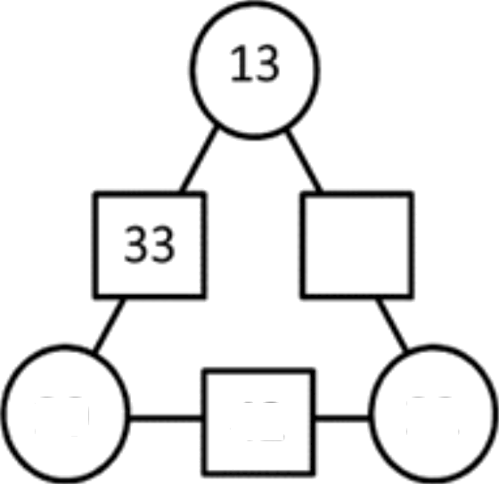

20

42

22

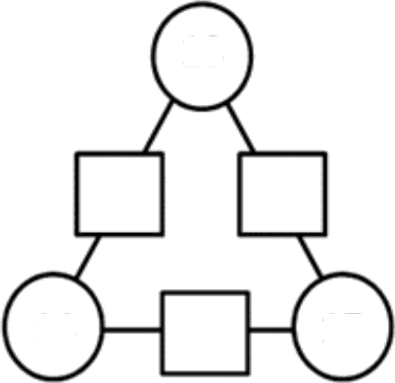

18

14

17

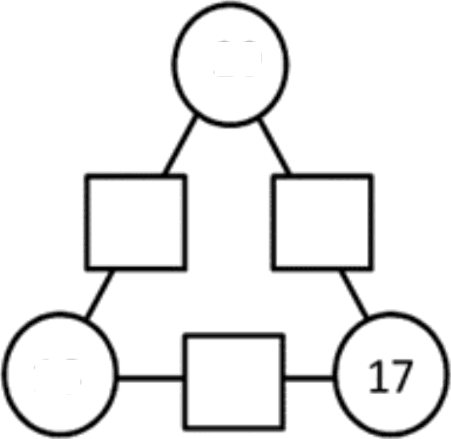

20

16

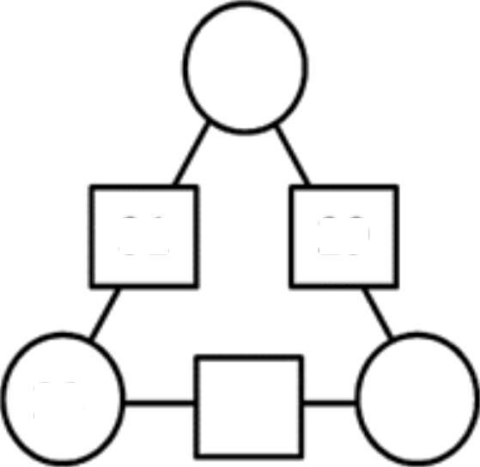

31

29

23

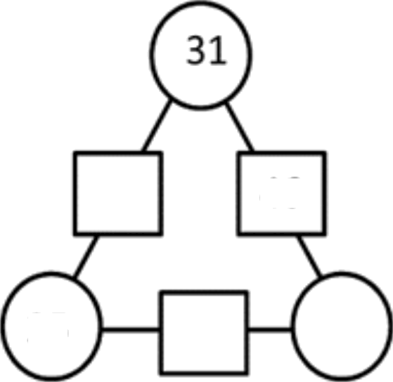

46

25

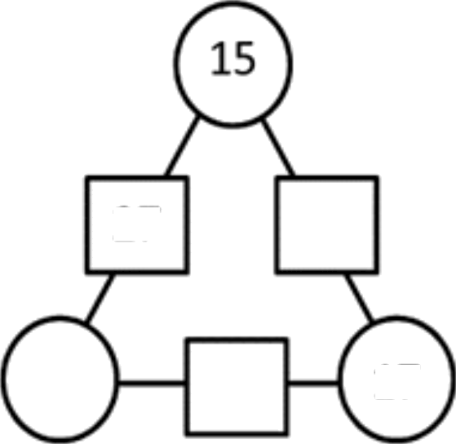

27

17

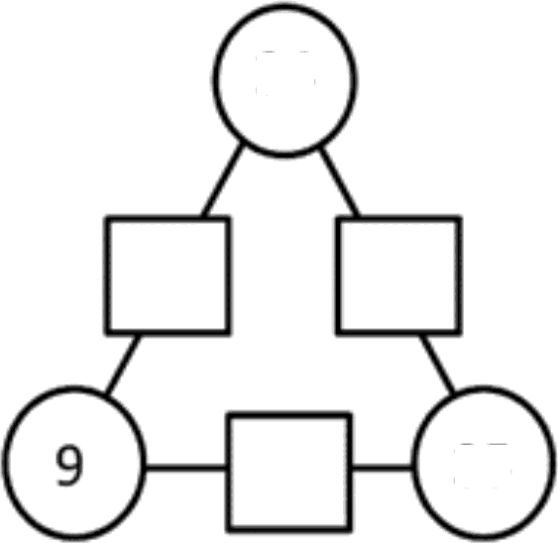

24

35

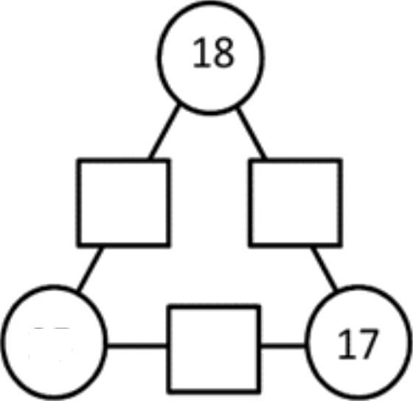

25

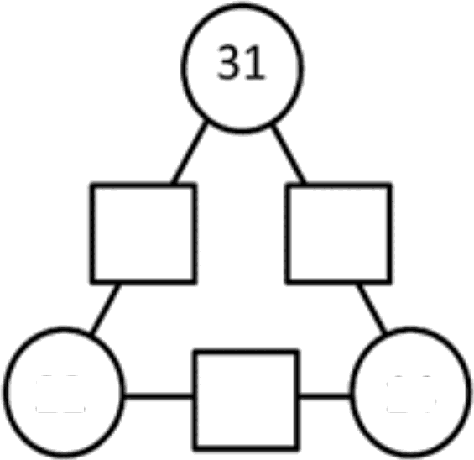

22

14

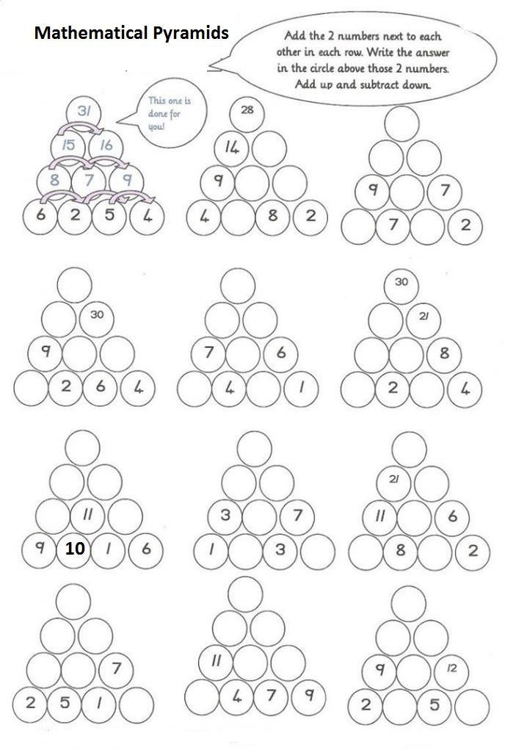

# Circle the correct option

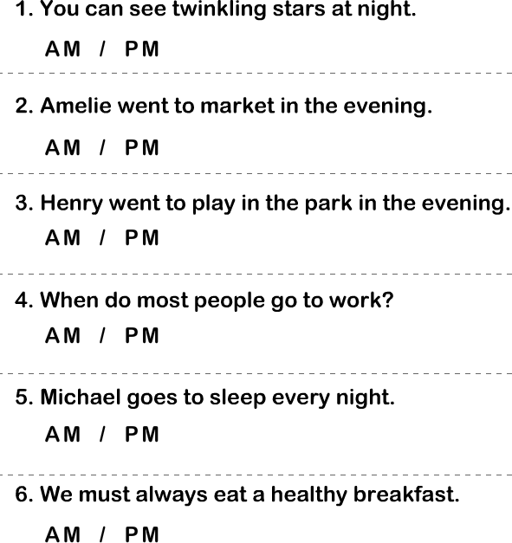

**Homework from book (Maths) :** Do Page no. 1 to 8 in book and the given sheets will be done in maths copy.

# SUBJECT – EVS

* 1. **Save Water Starts At Home**
* Try various ways to save water at home. Click your pictures and paste on a A-4 size coloured sheet and write five methods to save water on it.

# Write the body parts which rhymes with the following words :

* + 1. South -
    2. Nest –
    3. Tin –
    4. Harm –
    5. Band –
    6. Bye –
    7. Check –

# Feed a bird : Make and Place a few bird feeders or old pans with seed and water in them on your terrace to feed our flying friends this summer and write few lines on what you observe.

* 1. **In the table given below, Write five good habits and follow them.**

|  |
| --- |
| **GOOD HABITS** |
|  |
|  |
|  |
|  |
|  |

ANIMAL SOUNDS

**Identify the animals/birds name and match the sounds with the right animals/ birds-**

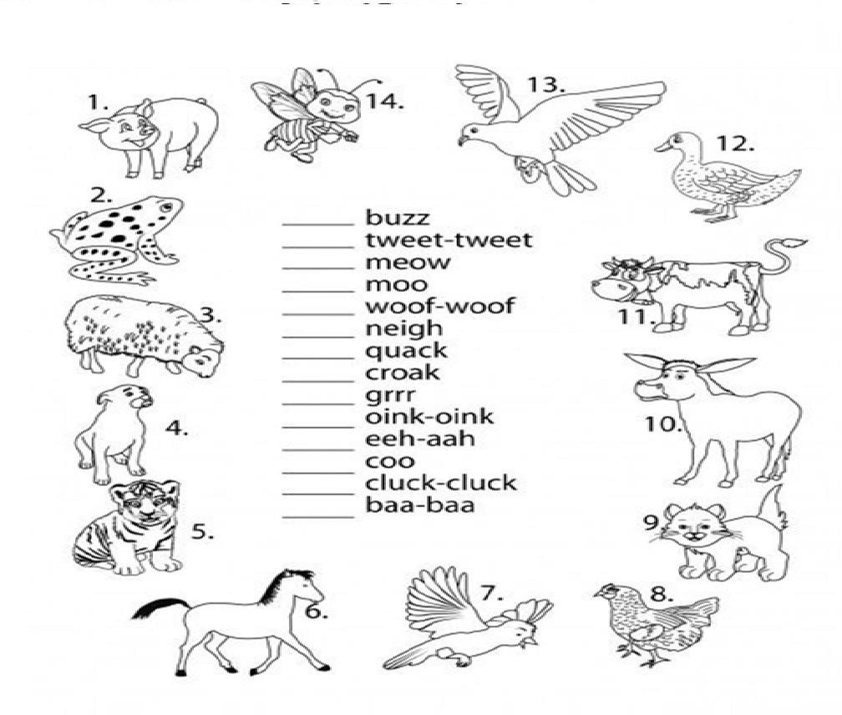

# The Gender of Nouns

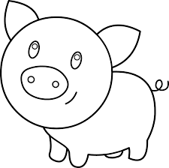

Fill in the blanks with the correct feminine pair you can find in the box-

|  |  |  |  |  |  |  |  |
| --- | --- | --- | --- | --- | --- | --- | --- |
| Bitch | Duck Cow  hind | bee  peahen mare | sow lioness  goose | | tigress ewe | | vixen hen |
| 1.Fox |  | | | 2.Peacock | | | |
| 3.Bull |  | | | 4.Lion | | | |
| 5.Drone |  | | | 6.Gander | | | |
| 7.Stag |  | | | 8.Drake | | | |
| 9.Boar |  | | | 10.Dog | | | |
| 11.Stallion | | | | 12.Cock | |  | |
| 13.Tiger | | | | 14.Ram | |  | |

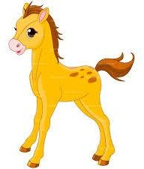

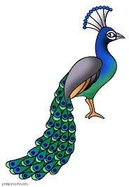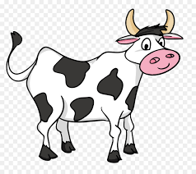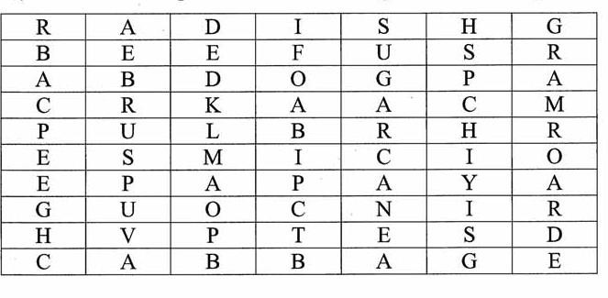

# Find the names of fruits and vegetables we use for eating and colour the grid :

**TABLE MAT ACTIVITY**

**THEME:- My Favourite Cartoon Character LEARNING OBJECTIVE: - Inculcating table manners MATERIAL REQUIRED:-**

* A4 size pastel sheet
* Poster colours
* Paint brushes

**INSTRUCTIONS**

Draw your favourite cartoon character on an A4 size sheet, color it beautifully and get it laminated.

This is your table mat which you can carry daily to school along with your tiffin box!

# Do one page cursive writing of English & Hindi daily in separate notebook.

* + **Learn three new words from dictionary daily and write them on A4 size sheet.**

**fo’k; fgUnh**



**¼1½ izR;sd ek=k ls nks&nks 'kCn cuk;s& vkvks fy[ksa&**

**v**

**v**

**vk k**

**b f**

**bZ h**

**m q**

**w**



**, s**

**_**

**`**

**,s S**

**vks ks**

**vkS kS**

**¼2½ esjk Ldwy ij ik¡p okD; fy[ksa&**

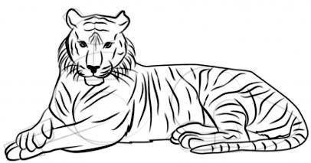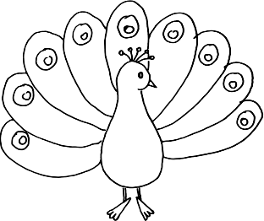

**--------------------------------------------------------------------------------------------------------------------------------------------------------------**

**--------------------------------------------------------------------------------------------------------------------------------------------------------------**

**--------------------------------------------------------------------------------------------------------------------------------------------------------------**

**--------------------------------------------------------------------------------------------------------------------------------------------------------------**

**--------------------------------------------------------------------------------------------------------------------------------------------------------------**

**¼3½ fp= ns[kdj jk"Vªh; fpg~u dk uke fy[ksa&**

|  |  |  |  |  |
| --- | --- | --- | --- | --- |
| **¼4½** | **la;qDr** | **v{kjksa** | **ls nks&nks 'kCn cukvks&** |  |
|  | {k |  | -------------------------------- | -------------------------------- |
|  | = |  | -------------------------------- | -------------------------------- |
|  | K |  | -------------------------------- | -------------------------------- |
|  | J |  | -------------------------------- | ------------------------------- |
| - |  |  |  |  |

# 

# Computer Holiday Homework

#### Draw or Stick pictures of 5 parts of computer in the notebook and label it.

* Draw or Stick any 3 pictures of input and output devices in the notebook and label them.
* Name the parts of the computer.

